**If we want our instances to clean /tmp directory everytime it is checked out**From EC2 management console go to lunch configuration go to expand advanced details is   
user data   
put select text   
write the below command given in screenshot for auto clean up whenever user tries to spin up the instance.  
  
yum update -y  
cd /tmp  
rm -rf *  
  
~~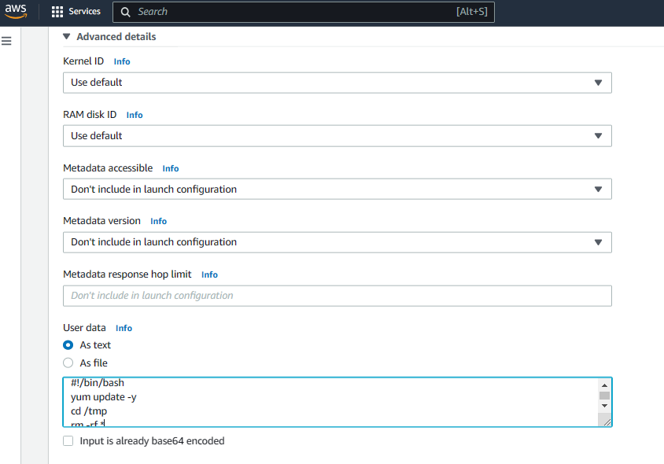~~  
 **Accessing instance from SSH client to do clean up activity**

another way is to login to Putty/ssh terminal from local system & we can configure the .pem file or .ppk files(attached below) to get login to the public IP of our instance. We can easily configure in putty to access the instance terminal & do whatever we wish to provided if we have root permission

  
